**CONTENTS**

**s.no name of the content** **pg.no**

1. Introduction

2. Air Traffic Management(ATM)

* Introduction
* Approach control
* Area control center

3. Communication Navigation surveillance (CNS)

* Introduction
* Basic Elements
* VHF Transmitter and Receiver
* Voice communication control system (VCCS)
* Digital voice tape recorder (DVTR)
* Doppler VHF Omni-directional radio range (DVOR)
* Distance measuring equipment (DME)
* Instrument landing system (ILS)
* Localizer and Glide path
* RADAR

**Introduction :-**

Airport is an aerodrome with extended facilities to travel the passengers safely and securely.

ICAO is the international civil aviation organization, a specialized agency of united nations. It was created after the convention on international civil aviation (the Chicago convention) of 1944 was ratified in 1947.

Within ICAO the 191 member states and a number of global aviation organization work together to develop international standards and recommended practicals(SARPs). These SARPs are the reference for the states developing their national civil aviation regulations which are legally enforceable.

This is an important aspect : ICAO SARPs are not legally binding by themselves, they form the basis of national regulations which have legal status.

ICAO has assigned an 26 alphabet (like A=Alfa, B=Bravo, C=charlie ---etc). to avoid miscommunication.

The code of the tirupati airport is VOTP.

Here the V stands for it is India. The letter V is common to all the airbuses in india.

O stands for the region (for tirupati it’s comes under southern region)

TP stands for local area (names of the locality)

Any air bus it consists of 5- 7 (letter as well as alphabet).

DGCA (Directorated general of civil aviation)

It is responsible for rules & regulations of air transport services to/from/within india and for enforcement of civil air regulations, air safety and airworthiness standards. It also co-ordinates all regulatory functions with international civil aviation organisation

Basically the airport has 6 main department like ATC,CNS, electrical department,civil, fire & recuse, terminal.

**AIR TRAFFIC MANAGEMENT ( ATM ) :**

Area control service is defined as air traffic control service for controlled flights in control areas.

Area control center is a unit established to provide air traffic control service to controlled flights in control areas under its jurisdiction.

Objectives of Air Traffic Services :-

1. Prevent collisions between aircraft on the maneuvering area and obstructions in that area.

2. Expedite and maintain an orderly flow of air traffic.

3. Provide advice and information useful for the safe and efficient conduct of flights.

4. Notify appropriate organizations regarding aircraft in need of search and rescue, aid and assist such organizations as required.

To achieve these objectives :-

ATS shall comprise of three services identified as follows :-

1. AIR TRAFFIC CONTROL SERVICE –It is further divided into three parts to accomplish

a) Prevent collision between aircraft.

b) Prevent collisions between aircraft on the maneuvering area and obstructions in that area.

c) Expedite and maintain an orderly flow of air traffic.

(a) AREA CONTROL SERVICE – to accomplish

i. Prevent collision between aircraft.

ii. Expedite and maintain an orderly flow of air traffic.

(b) APPROACH CONTROL SERVICE – to accomplish

i. Prevent collision between aircraft.

ii. Expedite and maintain an orderly flow of air traffic.

(c) AERODROME CONTROL SERVICE ( CONTROL TOWER) to accomplish

i. Prevent collision between aircraft.

ii. Prevent collisions between aircraft on the maneuvering area and obstructions in that area.

iii. Expedite and maintain an orderly flow of air traffic.

1. FLIGHT INFORMATION SERVICE– To Provide advice and information useful for the safe and efficient conduct of flights.

III. ALERTING SERVICE- To accomplish Notify appropriate organizations regarding aircraft in need of search and rescue, aid and assist such organizations are required.

AERODROME CONTROL SERVICE( Control tower) :-

Aerodrome control towers shall issue information and clearances to aircraft under their control to achieve a safe, orderly and expeditious flow of air traffic on and in the vicinity of an aerodrome with the object of preventing collision(s) between:

a) aircraft flying within the designated area of responsibility of the control tower, including the aerodrome traffic circuits.

b) aircraft operating on the maneuvering area.

c) aircraft landing and taking off.

d) aircraft and vehicles operating on the maneuvering area.

Aerodrome controllers shall maintain a continuous watch on all flight operations on and in the vicinity of an aerodrome as well as vehicles personnel on the maneuvering area. Traffic shall be controlled in accordance with the procedures set forth herein and all applicable traffic rules specified by the appropriate ATS authority. If there are other aerodromes within a control zone, traffic at all aerodromes within such a zone shall be coordinated so that traffic circuits do not conflict. Aerodrome control tower covers a region of 10 nautical miles.

**Approach control** :-

Approach control covers the region from 10 nautical miles to 60 nautical miles. Some of the functions in the provision of approach control service:

a) provide vectoring of arriving traffic on to pilot-interpreted final approach aids;

b) provide flight path monitoring of parallel ILS approaches and instruct aircraft to take appropriate action in the event of possible or actual penetrations of the no transgression zone(NTZ);

c) provide vectoring of arriving traffic to a point from which a visual approach can be completed

d) In accordance with prescribed procedures, conduct:

i) surveillance radar approaches;

ii) precision radar(PAR) approaches; and

e) provide flight path monitoring of other pilot-interpreted approaches;

f) provide separation between:

i) succeeding departing aircraft;

ii) succeeding arriving aircraft; and

iii) A departing aircraft and a succeeding arriving aircraft.

**Area control center :-**

It shall be provided by an area control center (ACC) or by a unit providing approach control service. There are a number of aspects regarding the provision of A.C. Service which are

i. Co-ordination and co-operate arrangements made with other ATC units.

ii. General working arrangements

iii. Control based on the integration and use of radar

iv. Providing navigational guidance and monitoring of light progress by radars and permit pilots to fly direct routes with the degree of accuracy upon which separation between aircraft is based.

v. Assignment of cruising levels for controlled flights.

vi. Provide essential traffic information.

vii. Provide alerting service and flight information service.

viii. Handle emergency situations.

**Communication Navigation Surveillance (CNS) :-**

The CNS (communication navigation surveillance) Communication, navigation and surveillance are the three basic facilities which aid civil aviation. Thus, CNS are the three pillars of air traffic management.

The block diagram of CNS is

CNS

**COMMUNICATION** :-

Communication, navigation and surveillance are the three basic facilities which aid civil aviation. Thus, CNS are the three pillars of air traffic management. Communication is a process of transfering information from one source to another. Communication is commonly defined as “the imparting or interchange of thoughts, opinions or information by speech, writing or signs”. Communication can be perceived to be a two way process. But in civil aviation it is a one way process. At any time either the controller can speak or the pilot can speak.



FIG:-communication between two systems

It can be further classified as:

**• Ground to Ground**: This enables various stations in the AFTN (Aeronautical Fixed Telecommunications Network) to communicate via low or high speed links. Various messages containing important information are exchanged. The communication is based on store and forward principle.

**• Ground to Air**: This includes all the communication between controllers and the pilot. It may include voice communication or any DATIS or any other form of messages.

Ground to air communication generally uses either VHF or HF frequencies. Communication takes place through transmitters and receivers installed on the ground as well as on board the aircraft. VHF and HF are used for Voice Communication.

• **Air to Air**: This may include communication between the pilots of two aircrafts in the air. Such type of communication also uses VHF and HF frequencies.

**Communication Facilities available**:

VHF Transmitter/Receiver ,Voice Control System (VCS) , Direct Speech Circuit (DSC), Digital Airport Terminal Information system ( DATIS), Automatic Message switching System (AMSS),

VHF is less affected by atmospheric noise and interference from electrical equipment than lower frequencies. But are more easily blocked by land features than HF and lower frequencies, VHF are line-of-sight frequencies with practically no ground-wave element. Provides high-quality communications. The range of antennas increases with height. VHF is less affected by buildings and other less substantial objects than UHF frequencies. In spite of being line-of-sight communication, long-range communications using VHF are possible through repeater stations and satellite links.

**Basic elements:**

Wireless communication system consists of three main parts

1. A transmitter that takes information and converts it to a signal.
2. A transmission medium, also called the physical channel that carries the signal. An example of this is the "free space channel".
3. A receiver that takes the signal from the channel and converts it back into usable information for the recipient.

**GENERAL TRANSMITTER :-**

**Antenna**

MODULATION

IMPEDANCE MATCHING

AMP

CARRIER SIGNAL

MODULATING SIGNAL

**Fig:-** Block diagram of General Transmitter

**GENERAL RECEIVER :-**

**ANTENNA**

**DISPLAY/ SPEAKER**

**DEMOD**

**IF FILTER & AMP**

**MIXER**

**RF AMP**

**LO**

**Fig:-** Block diagram of General Receiver

**Frequency band in communication:-**

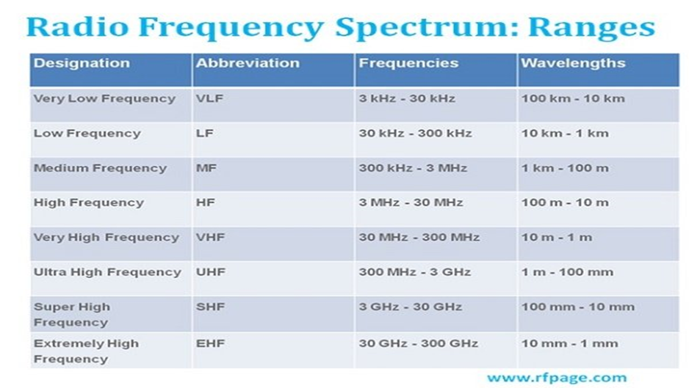

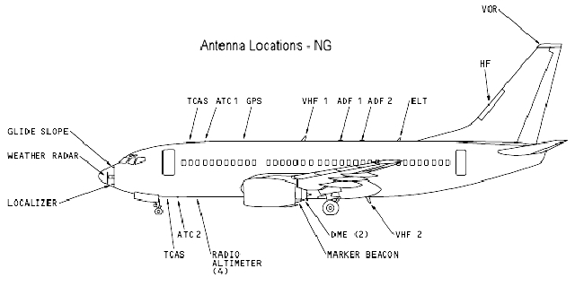

**VHF INTRODUCTION :**

Very high frequency range is 30MHZ to 300MHZ and the wavelength is about 10m – 1m.

VHF is generate by the equipment called VHF equipment. ICAO will allocate the certain frequency for all the airport in the world. The range of VHF is **(118MHZ-136MHZ)**.

* The 117.975 to 136.975 MHz VHF aeronautical band
* The 138.000 to 156.000 MHz upper military VHF band

Generally every airport station is provided the VHF frequency which is called as main frequency. If it is interphase with noise or JAM the VHF frequency then there is provide with the S/BY for trasmitter and receiver.

And there is an **Emergency VHF frequency 127.85**

VHF frequency of Tirupati airport is **main frequency is (119 MHZ)**

**S/BY frequency is (124.3 MHZ)**

**VHF Antenna :**

**Folded Dipole Antenna (FDA) :-**

* Two conductors connected on both sides, and folded to form a cylindrical closed shape, to which feed is given at the center.
* The length of the dipole is half of the wavelength. Hence, it is called as half wave folded dipole antenna.

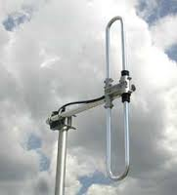

**Fig:-** Folded dipole antenna

**Advantages :-**

* More Bandwidth
* More Input Impedance

***VHF Transmitters and Receivers:***

The transmitters and receivers used in the equipment room have both main and standby which operate continuously from time to time. Both of these use VHF (Very High Frequency) the range of which is 30 to 300 MHz. The power supply used here is both D.C. and A.C. If AC supply fails UPS will take over for the main and standby transmitter and receivers. Generator supply is also provided for the uninterrupted operation of the transmitter and receivers.

The transmitter used here is : DT 100(Digital transmitter 100)

The receiver used here is : DR 100(Digital receiver 100)

There is also device in which both transmitter and receiver is together which is the Transceiver and the common one used is the

DTR 100(Data transceiver 100)

**Transmitter:**

The transmitter contains the following functional modules:

1. Power supply.
2. Base Band module.
3. Transmitter Section.
4. Control Panel and display.

The TX (transmitter) contains

* CPU which is a microcontroller.
* CPLD (Complex Programmable Logic Device).
* Flash memory and EEPROM.
* Digital to Analog converter.
* Driver to test the interface port.

TheRF Section contains

* Anti aliasing filter(low pass filter)
* Modulators.
* Linearization stage.
* Signal detector.

**Operating modes of DT 100:**

**1) AM DSB ( Amplitude Modulation Double side band):**

This mode is used only when transmission of analog speeches is from ground to air.

**2) AM Data:**

This mode is used only when transmission is required for aircraft communication address reporting system.

**3) VDL 2 Mode ( VHF Data Link Mode 2):**

This mode allows data link between airborne radio equipment and ground station.

**4) VDL 2 LAAS Mode ( VHF Data Link Mode 2 Local Area Augmentation System):**

This mode allows for transmission of data only from the ground station towards air borne radio equipment.

**5) VDL 3 Mode ( VHF Data Link Mode 3):**

This mode allows up to four simultaneous connections with several combinations of digitalized voice and data in 25 kHz channel spacing.

**6) VDL 4 Mode:**

This mode is also known as the STDMA which is known as Self organizing Time Division Multiple Access.

**DT 100 Operating frequency bands:**

The DT 100 operates between **108** to **156 MHz**.

It is classified as follows:

* **117.975** to **136.975 MHz** – This range of frequency is used for VHF Aeronautical band.
* **138** to **156 MHz** – This range of frequency is used for upper military VHF.
* **108** to **136.975 MHz -** This is used for VDL 4 band.

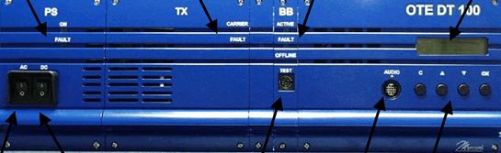

**Receiver:**

Receiver contains the following modules:

1. Power supply.
2. Base Band Module.
3. Receiver Section.
4. Control Panel and display.

The RX (Receiver) board contains

* + First intermediate frequency Stage (IF).
  + Second intermediate frequency Stage.
  + Channel selection stage.
  + IF AGC (Automated Gain Control).
  + Local Oscillator synthesis section.
  + DC regulators.

**Base Band module:**

It is a module for signal processing. It provides all reference clock signals. It contains microcontroller, digital signal processor, FPGA (Field Programmable Gate Array) and clock generators.

**Different frequencies used in transmitters and receivers:**

* **119MHz** – This frequency is used in Control tower for aircraft communication
* **161.125MHz –** This frequency is used in control tower for Ground communication.

**VOICE COMMUNICATION CONTROL SYSTEM(VCCS):-**

Among other important systems in an airport, like radar, instrument landing system, etc., the

voice communication system can be seen as the nerve system of the airport. It serves as the

sole communication system between the pilots, the air-traffic control personnel working on the airport, other parties external to the airport and even other airports.

The voice communication control system (VCCS) is a voice switch and control system for networking an airport VHF communication system. It is an electronic switching system, which controls the complex floe of speech data between air traffic controller on ground and aircraft. The system has been designed using complementary metal oxide semiconductor (CMOS) digital circuits and is very easy to operate.

Voice communication system is a switching system which connects the various Air traffic

controller positions to various Air-to-ground (A/G) and Ground-to-ground (G/G) communication systems. Voice switching and routing between the (A/G and G/G) communication systems and air traffic controller working positions is done using advanced microprocessor and DSPs

* It is based on the Integrated Communications System ICS 200/60.
* The ICS 200/60 uses the most advanced digital technology based on the standard 2 Mbps PCM bus, including powerful microprocessors, digital signal processors and fast, non‐blocking switching components.
* 200 – Operator Positions/Controller Positions
* 60 - Time slot/Analog- Digital (59 Voice data and 01 Digital Data)
* The ICS 200/60 consists of three main subsystems, which are:

The server system

The interface system

The operator position rings

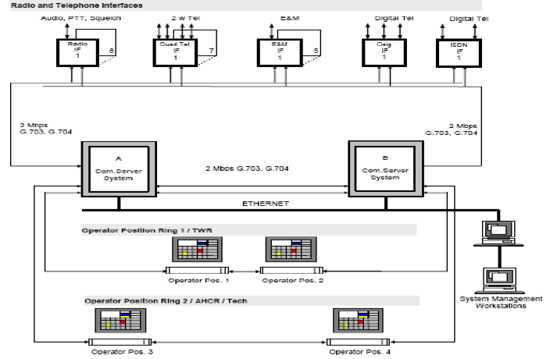

The VCCS is used for operation of different main/standby transmitters, receivers between ground and air craft. It is also used for intercommunication among all the VCCS positions at all the stations.

**DIGITAL VOICE TAPE RECODER(DVTR):-**

Recording and storage of all voice communications is a basic requirement for air traffic control units. The requirement applies to all communication, i.e. ground-ground communications (G/G) and air-ground communications (A/G). The G/G is the communications among air traffic control units or centers where as the A/G communication is between air traffic controllers and pilots.

Recording facilities shall be provided on all voice communication channels. Each station is provided with multi channel voice recording systems (analog/digital) for recording of channels which includes operational voice communications on all ATS channels and all important telephones and intercoms.

It is a digital communication system using a central switching matrix for routing calls between different work stations connected in a star format.

The digital central switching matrix uses a microprocessor for control and configuration process. It has a matrix card which allows switching and routing. Other facilities available are GPI inputs and outputs. Analog audio data interfaces and advanced software packages.

The digital control panel provides a touch interface for making and receiving calls over the system. Audio sent and received digitally multiplexed using a category 5 cable.

**Specifications:**

Power requirements: 90V to 250V

50 to 60 Hz, 300W max

Frequency response: 130Hz to 17KHz

**Digital control panel:**

Power requirements: 85 to 265V ac

45W max

Typical key response time: <50ms for audio route

System Temperature range:

**Operating**: 0 to 40 C

**Storage**: -55̊ to 70 C.

***DIGITAL CLOCK***

Greenwich Mean Time (GMT) is used for synchronization between every airport.

***DATIS:***

Digital Airport Terminal Information Service. It records weather conditions and sends it at a frequency of 126.6 MHz. It is updated every 30 minutes. The report is updated and stored in memory. The aircraft which requires terminal information can tune to this frequency and get the information. DATIS provides recording and announcing system for continuous transmission of audio messages on VHF frequency related to runway weather. The parts of the system are recording system, remote recording controller and UPS.

**NAVIGATION :-**

Navigation is the ART of determining the position of an aircraft over earth’s syrface and guiding from one place to another.

To accomplish this ART some sort of aid are required by the pilots.in the early days, voyages were accomplished by the navigation the knowledge of terrain or movements of sun, stars and winds. As the time progressed, some instruments such as compass, chronometer and theodolite came on the scene.

In the twentieth century, electronics also entered in the aviation field, direction finders and other navigational aids enabled the navigators to obtain fixes using electronics aisds only.

**RADIO NAVIGATION:-**

This method is based on the use of Radio Transmitter, Radio Receiver and propagation of electromagnetic wave to find navigational parameters such as direction, distance etc., required to find position of the aircraft.Radio Navigational aids provide information to the pilot regarding the position of his/her aircraft in azimuth and/or elevation at any instance of time. Radio communication and navigational aids also provide useful information to Air Traffic Control Officers for effective control of air traffic.

## Doppler Very High Frequency Omnidirectional Radio Range (DVOR)

VOR (Very High Frequency Omnidirectional Radio Range) is a radio navigation aid which has been recommended by ICAO and submitted to international access to guide short/medium-haul aircrafts. İt is controllable and traceable remotely. DVOR is developed version of CVOR radio navigation aid systems. A broad-based antenna system uses the Doppler effect,thus highly accurate horizontal signal may be provided.

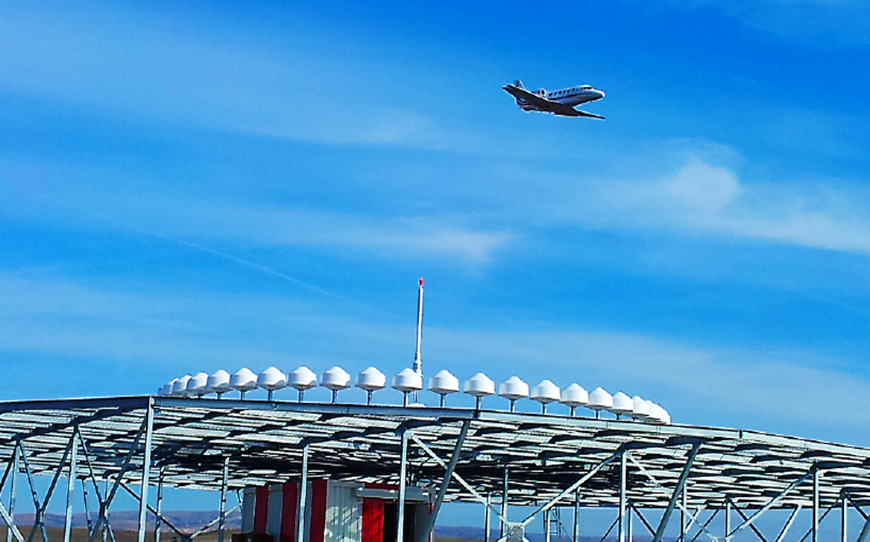

**FIG:- DVOR Tower With 49 antennas**

DVOR's are devices which isdesingned to be used in forestry areas, mountainous regions where have denslybuilded areas and the regions where high-voltage lines exist. These devices are identical to those of Conventional VOR devices but variable signal is not be delivered from a single cross-dipole array. DVOR system uses antenna system which is consisting of 36 or48 antenna array sorted circularly around the omnidirectional antenna which located in airport.

# VOR Navigation System:-

The Very High-Frequency (VHF) Omnidirectional Range (VOR) system is used for [air navigation](https://www.thebalancecareers.com/how-do-pilots-navigate-282803). Though older than [GPS](https://www.thebalancecareers.com/the-global-positioning-system-for-pilots-282831), VORs have been a reliable and common source of navigation information since the 1960s, and they still serve as a useful navigational aid for many pilots without GPS services.

### Components:

A VOR system is made up of a ground component and an aircraft receiver component.

Ground stations are located both on and off airports to provide guidance information to pilots both en route and during arrival and departure.

Aircraft equipment includes a VOR antenna, a VOR frequency selector, and a cockpit instrument. The instrument type varies but consists of one of the following: an Omni-Bearing Indicator (OBI), Horizontal Situation Indicator (HSI) or a Radio Magnetic Indicator (RMI), or a combination of two different kinds.

Distance Measuring Equipment (DME) often is collocated with a VOR to give pilots a precise indication of the aircraft's distance from the VOR station.

VORs have AM voice broadcast ability, and each VOR has its own Morse code identifier that it broadcasts to pilots. It ensures that pilots are navigating from the correct VOR station, as there often are many VOR facilities within range of a single aircraft.

### How it Works:

The ground station is aligned with magnetic north and emits two signals—a 360-degree sweeping variable signal and an Omni-directional reference signal. The signals are compared by the aircraft's receiver, and a phase difference between them is measured, giving a precise radial position of the aircraft and displaying it on the OBI, HSI, or RMI.

VORs come with high, low, and terminal service volumes and dimensions. High-altitude VORs can be used up to 60,000 feet and 130 [nautical miles](https://www.thebalancecareers.com/nautical-miles-vs-statute-miles-282937) wide. Low-altitude VORs service aircraft up to 18,000 feet and up to 40 nautical miles wide. Terminal VORs go up to 12,000 feet and 25 nautical miles. The network of VORs typically provides thorough coverage along published visual flight rules (VFR) and instrument flight rules (IFR) routes.

### Errors :

As with any system, VORs come with some potential problems. While more accurate and usable than the old [nondirectional beacon (NDB) system](https://www.thebalancecareers.com/the-adf-ndb-navigation-system-282773), VORs are still a line-of-sight instrument. Pilots flying in low or mountainous terrain may find it difficult to successfully identify a VOR facility.

Also, there exists a "cone of confusion" when flying near a VOR. For a brief period when an aircraft flies near or over the top of a VOR station, the aircraft instrument will give erroneous readings.

Finally, VOR ground systems require constant maintenance, and they commonly are out of order for short periods of time while maintenance is performed.

### Practical Applications :

After tuning to a VOR facility's frequency and identifying that the Morse code is correct, pilots can determine on which radial to or from the VOR station the aircraft is located. The OBI, HSI, or RMI indicator in the cockpit looks like a compass or a heading indicator, with a superimposed Course Deviation Indicator (CDI) needle on it. The CDI will align itself with the radial the aircraft is on. Paired with DME, a pilot can determine a precise location from the station.

Also, the use of two VOR stations makes determining a precise location even more accurate by using cross-radials, even without DME.

Pilots fly certain radials to or from VORs as a primary way of navigating. Airways often are designed to and from VOR facilities for ease of use.

In its more basic form, a VOR facility can be used to go directly to an airport. A large number of VOR facilities are located on airport property, allowing even student pilots to fly directly to a VOR to find the airport easily.

The VOR system is at risk of being decommissioned by the FAA due to the popularity of new technology such as GPS, [wide-area augmentation systems (WAAS)](https://www.thebalancecareers.com/wide-area-augmentation-system-waas-282839), and automatic dependent surveillance-broadcast systems (ADS-B). As of 2018, pilots still use VORs as a primary navigational aid, but as more and more aircraft are equipped with GPS receivers, VORs most likely will be retired from use.

**Navigation:**

It is the ‘ART’ of determining the position of an aircraft over earth’s surface.

If this position of the aircraft is finding using the radio Tx’s/Rx’s and EM waves then it is called as Radio Navigation.

**According to service range**, the radio navigational aids are broadly classified into three categories:

* Long range – Upto 3800NM (Not in AAI)
* Medium range - 150 – 250 nautical miles (NM), and even up to 350 NM
* Short range - Upto 40-50NM

How we are fixing the position of the Aircraft?

* It is based on the principles of Rho-Theta(Polar coordinate) Navigation System.
* Theta- Azimuth(by VOR) and Rho-Distance(by DME)
* DME channels being paired with the VHF frequencies used by the VOR/Localiser equipment (so no need to tune particular DME freq).

Is DME giving horizontal distance w.r.t ground surface?

* No, DME records Slant Ranges which are greater than the actual distance.

Error????

* If the Aircraft is at below 5000 feet, close to the ground transponder, then the discrepancy is small and can be ignored for all practical purposes.

**Principles of operation of DME:**

Radar principle- The time required for a radio pulse signal to travel to a given point and return.

In fact it is a Secondary Radar- targets active participation is required

* The airborne transmitter repeatedly initiates a process of sending out very short, very widely spaced interrogation pulses. These are picked up by the ground transponder receiver whose output triggers the associated transmitter into sending out reply pulses on a different channel.
* The airmborne receiver receives these replies. Timing circuits automatically measure the round-trip travel time, or interval between interrogation and reply pulses, and convert this time into electrical signals, which operate the distance indicator.

***Airborne Equipment***

*The Aircraft Interrogator transmits*

*an omnidirectional interrogation*

*the interrogation travels at*

*speed of light*

*Distance = Total travel time - 50µs*

*12.36µS/nm*

*Reply travels at speed of light*

Internal delay

50 µs

*Ground*

*equipment*

*Uses a pseudo-random timing algorithm to*

*recognize the replies to its own interrogations.*

**Distance Measuring Equipment (DME):-**

**Definitions:**

**Distance Measuring Equipment (DME)** is defined as a navigation beacon, usually coupled with a VOR beacon, to enable aircraft to measure their position relative to that beacon. Aircraft send out a signal which is sent back after a fixed delay by the DME ground equipment. An aircraft can compute its distance to the beacon from the delay of the signal perceived by the aircraft's DME equipment using the speed of light.

It  is defined as a combination of ground and airborne equipment which gives a continuous slant range distance-from-station readout by measuring time-lapse of a signal transmitted by the aircraft to the station and responded back. DMEs can also provide d time-to-station readouts by differentiation.

Distance measuring equipment (DME) is a system requiring both aircraft-installed and ground-based equipment, with the latter normally co-located with a VHF omnidirectional radio range (VOR) or, sometimes, an instrument landing system (ILS). It provides the pilot with the slant-range distance to the DME transmitter. Slant-range distance will always be slightly greater than the flight-planned distance to a DME station, because it also includes the aircraft’s height above the station—the DME display in an aircraft 6,000 feet directly above a DME transmitter will read one nautical mile.

Although DME operates in a separate frequency band, its frequencies are paired with a VOR, ILS, or localizer frequency. When the pilot of a DME-equipped aircraft tunes the frequency of a VOR (or ILS) with DME, the frequency of the co-located DME is automatically tuned. The aircraft interrogates the DME ground station with a pulsed signal, and the station replies. Aircraft equipment measures the time between transmission and reception to determine the distance; from that, groundspeed and time to station can be derived.

Thanks to the global positioning system (GPS), pilots don’t rely on DME as much as they used to, although DME—or an IFR-approved GPS—is still required for some instrument approach procedures. And if you fly high, DME might be mandatory: If FAR 91.205(d)(2) requires VOR navigation equipment, then an approved DME or a suitable RNAV system is required for flight at or above flight level 240.

An interesting fact about DME transmitters: You may not be able to receive one if it’s overloaded. When a ground station receives more interrogations than it can process—stations are rated for 100—it automatically reduces receiver sensitivity, and will not respond to queries from aircraft farther away.

**INSTRUMENT LANDING SYSTEM:-**

INTRODUCTION :

The ILS (Instrument Landing System) is a navigation aid used internationally to facilitate approach and landing. It is comprised of a localizer (LLZ or LOC), a glide path (GP or GS) and a series of marker beacons that includes an outer and middle marker and, in special cases, an inner marker. Each group generates radio signals independently and simultaneously. The localizer supplies left−right navigation information, the glide path supplies up−down navigation information, and the marker beacons supplies distance−to−threshold information. The system includes equipment in the control tower that can be used to remotely control, monitor, and maintain the localizer, glide slope and markers. The localizer and the glide path principle of operation is based on measurements of the difference in depth of modulation (DDM) between two signals with frequencies 90 Hz and 150 Hz. These are the navigation frequencies used to detect the correct approach course (DDM = 0) and the specified glide path angle (DDM = 0). The localizer operates in the frequency range of 108 to 112 MHz and generates a vertical guidance plane, which permits the aircraft pilot to select a left/right approach course from a distance of up to about 30 km. The antenna radiation pattern reveals exactly the same amplitude for the two modulation frequencies of 90 and 150 Hz in the guidance plane. If the pilot deviates to the left of the guidance plane, the 90 Hz modulation signal will predominate causing the cockpit indicator to show a fly right indication. If the pilot deviates to the right, the 150 Hz modulation signal will predominate causing the cockpit indicator to show a fly left indication (Fig. 1−1). The glide path operates in the frequency range between 328 and 336 MHz and generates the glide path plane, which is elevated above the runway by the glide angle. The antenna radiation pattern results from an interaction with the earth’s surface, and contains predominantly 150 Hz modulation below the glide path plane and predominantly 90 Hz modulation above the glide path plane. In the glide path plane itself the amplitudes of the two modulation signals are equal.

The beam which shows the aircraft the correct landing approach path is formed by the intersection of the vertical course guidance plane and the horizontal glide path plane. In addition, the marker beacons provide marks that indicate the distance from the runway thresholds. The marker beacon transmitters radiate vertically upwards at the same carrier frequency, and are characterized by various continuously keyed Morse code signals and different modulation frequencies.

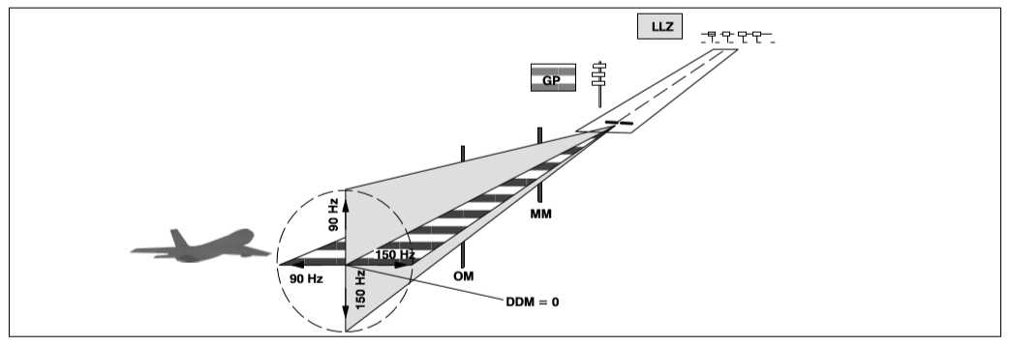

The main features of the NAV 400 family in general and the ILS 420 in particular are as follows: High compatibility: The ILS 420’s electronics are compatible with all of Thales ATM’s many antenna types and configurations. They are also compatible with previous Thales ATM (SEL, Alcatel Air Navigation Systems, Face, Thomson−CSF, and Wilcox) antenna configurations. The flexibility facilitates cost−effective update by allowing to combine the ILS 420 electronic subsystem with existing arrays. High−power output: The robust output powers of the Glide Path (5 W) and the Localizer (25 W) provide excellent coverage for challenging sites and for many types of antenna arrays. High configuration flexibility: The ILS 420 has been designed to meet any site’s needs. Its many configurations can be combined to suit your requirements, from the simplest CAT. I application to the most complex CAT.III application. A summary of the main ILS configuration options are: single or dual frequency single or dual transmitter/monitor equipment seven Localizer antenna subsystems four Glide Path antenna subsystems optional environmental sensor package DME compatibility (can replace markers) optional field monitors LLZ course and displacement sensitivity far−field monitoring (FFM) LLZ and GP near−field monitoring (NFM) 10 ft shelters with pre−installed LLZ or GP equipment available Easy setup and maintenance: All of the ILS 420 system parameters can be setup, adjusted, and monitored locally or remotely with the PC. User−friendly: The maintenance software (ADRACS or MCS) is very user−friendly and facilitates troubleshooting to the modular level. Secure: ADRACS resp. MCS uses passwords to control operator access by level and proficiency. Simple and quick equipment firmware updates: The ILS 420 firmware incorporates "Flash Memory" technology that eliminates the need to replace EPROM’s* during updates. Instead, updates are quickly and conveniently achieved in the field through software alone. (* Erasable Programmable Read−Only Memory) Advanced equipment supervision: The advanced remote monitoring and control system is a powerful tool for centralizing technical expertise and support. Its versatility and scalability allow it to meet the spectrum of usage needs, from servicing one site or a nation wide matrix of navigational equipment. With it, support personnel can monitor many systems from one location and can respond to maintenance needs anywhere in the network much more quickly than in typical maintenance organizations. This strategy uses personnel and resources more efficiently and creates significant long−term savings. The monitoring system supports simultaneous NFM/FFM (LLZ) configurations and integral inputs. Its far−field monitor system meets the latest ICAO requirements and includes an executive control option.

**Arrangement of Subsystems :**

See Fig. 1−2. The basic subsystems belonging to the ILS system, namely − the Localizer (LLZ) − the Glide Path (GP) − and the Markers (MM, OM) and in addition − a DME (optional) − and a Far Field Monitor (FFM) for the localizer (optional) are arranged on the runway as shown in Fig. 1−2. This arrangement is valid for the single and dual frequency (1F, 2F) installations described in further detail below.

The LLZ antenna is located 200 to 360 m beyond the end of the runway on the extended centre line. The associated LLZ transmitter is in a shelter near the antenna.

The GP antenna is located 120 to 180 m from the runway center line. The reference height for the glide path has been fixed at 15 m above the runway threshold. The dimension "D" (286 to 344 m) between the GP antenna mast and the runway threshold is calculated from this height and the glide angle, the latter being determined on the basis of local circumstances. The associated GP transmitter is in a shelter in near the antenna.

The inner marker (IM) is 75 to 450 m ahead of the runway threshold on the extended centre line, the middle marker (MM) is 1050 m ahead, and the outer marker (OM) is 7200 m ahead. In most cases only the middle and the outer marker are used.

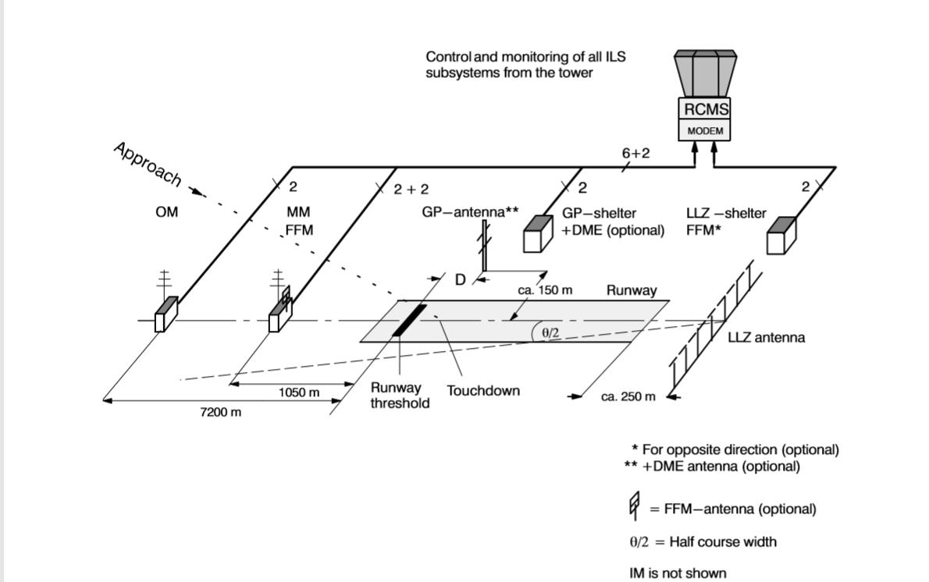

**Localizer:**

The LLZ generates an RF−signal in the frequency range of 108 to 112 MHz, which is modulated in amplitude with 90 and 150 Hz. This signal identifies the "course plane" and is produced by a transmitter and antenna system, which can be a 2F system with 25 W transmitter power or a 1F system with 30 W transmitter power. The localizer signal is obtainable up to a distance of up to 25 nautical miles (approx. 46 km) for a sector of ±10°, and it is obtainable up to a distance of 17 nautical miles (approx. 31 km) for a sector of ±35° relative to the course line and the LLZ−antenna. The characteristic values for LLZ within certain sectors, and in relation to the runway center line, are as follows: − DDM = 0 − DDM = 15.5 % (0.155) − DDM 18 % (0.18) DDM 0 exists when the approach direction corresponds exactly to the runway center line. DDM 15.5 % characterizes the course sector selected such that the boundary at the level of the runway threshold is 107 m to the left and right of the runway with respect to the center line. These points are also known as WIDTH points. The DDM has a linear characteristic within these points and an elevation of 0.145 % per meter. This results in approx. 107 m for the half sector calculated for DDM=15.5 %. ICAO Annex10 (4th Ed., April 85, section 3.1.3.7.3, Note1) assumes a nominal sector width of 210 m (700 ft). DDM 18 % characterizes a sector of ±10°and DDM 15.5 % characterizes a sector of ±10° to ±35° where correct LLZ information is still ensured. In the LLZ−1F, this sector is covered by a specifically formed antenna pattern, and, in the LLZ−2F system, it is covered by an additional clearance signal (see also section 1.2.4). The course information consists of 90 and 150 Hz amplitude−modulated signals. When the aircraft is approaching the runway on the desired course, the air−borne receiver receives the two modulation signals with equal amplitudes. This state corresponds to DDM 0. If there is a leftward deviation from the desired course, there will be a predominant 90 Hz amplitude, and if there is a rightward deviation there will be a predominant 150 Hz amplitude.

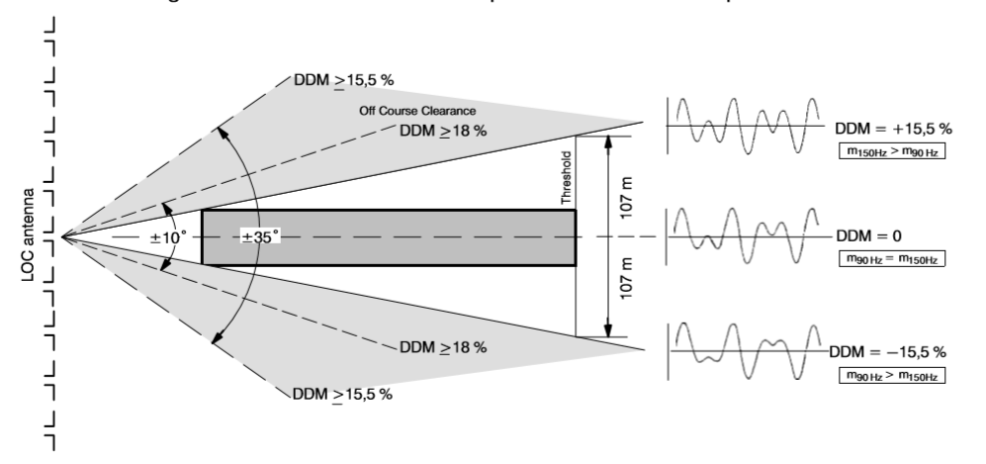

**Glide Path :**

The GP generates an RF−Signal in the frequency range of 328 to 336 MHz that is modulated in amplitude with 90 and 150 Hz. The signal to identify the "glide path plane" is achieved by a transmitter and antenna system. The transmitter can be a 2F system or 1F system, but both produce up to 5 W of power. The glide path signal is obtainable up to a distance of 10 nautical miles (approx. 18.5 km) within an azimuthal sector of±8° relative to the localizer course line with the touch down point as reference and between the elevations 0.30 to 1.75 , wherea is the nominal glide path angle. Below the glide path sector the DDM increases smoothly for decreasing angle until a value of 22 % is reached. From there to 0.45 to 0.3 the DDM is not less than 22 % as it is required to safeguard the promulgated glide path intercept procedure (turning to the guide beam). The characteristic values for GP within certain sectors and in relation to the runway center line are as follows: − DDM = 0 − DDM = 17.5 % (0.175) − = 2.5...3° (typical) The plane DDM 0 radiated by the glide path antenna is hyperbolic and does not touch the ground, as the dotted line shows. According to ICAO Annex 10, section 3.1.1, the reference height of this curve has been fixed at 15 m (ILS reference datum) at the runway threshold. Taken together with the specified glide angle of = 2.5 to 3° this produces an offset of the glide path antenna mast with respect to the runway threshold of the distance D. This offset is 286 to 344 m depending upon the glide path angle selected (see Fig. 1−2). Due to this the optimal vertical glide path is not a straight line in azimuth direction of the center line of the extended runway, it is a hyperbola. DDM=17.5 % is specified for glide angle deviations of ±0.24 from the nominal glide path ( DDM 0). These values correspond to the WIDTH. The DDM characteristic is linear within this sector (±0.24 ). Like the localizer the glide path’s angle information consists of signals amplitude−modulated with 90 Hz and 150 Hz. When the aircraft approaches the runway on the desired glide path, the airborne receiver receives both signals with equal amplitude (equivalent to DDM 0). Deviations above the nominal glide path will result in a predominant 90 Hz amplitude, and deviations below will result in a predominant 150 Hz amplitude (positive DDM).

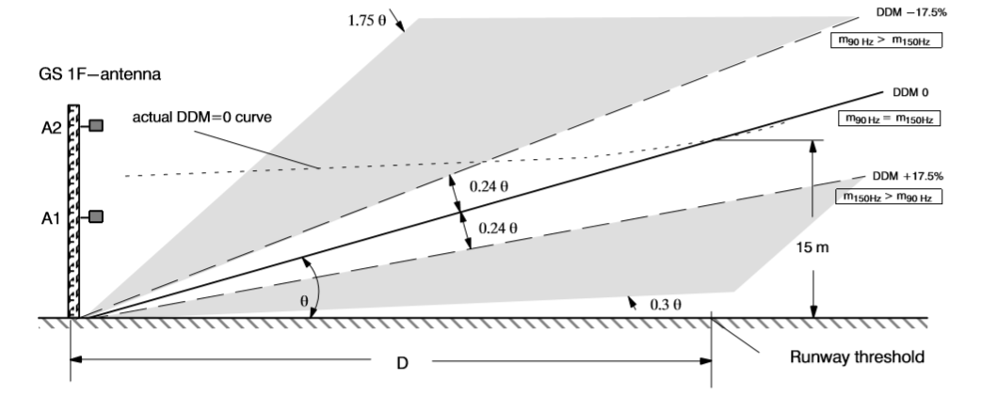

**Approach Path :**

The nominal approach path to the runway is obtained from the intersection of the planes generated by LLZ and the GP. Both planes contain the above−mentioned 90 Hz and 150 Hz modulation signals. These signals are interpreted by the airborne receiver and supplied to a cross−pointer instrument, which displays control information to the pilot corresponding to deviations from the nominal course and glide path. The signals interpreted by the airborne receiver can also be supplied to the auto−pilot. In addition, the pilot receives distance information via two (three) marker beacons. The 2 (under normal conditions) or 3 (in special cases) marker beacons are set out at a distance of − 75 m (inner marker in special cases) − 1050 m (middle marker) − 7200 m (outer marker) from the runway threshold. Each of these marker beacons transmits a particular pulse code vertically upwards at a carrier frequency of 75 MHz. The identity frequencies are: − 3000 Hz (inner marker) − 1300 Hz (middle marker) − 400 Hz (outer marker) The aircraft flies through the transmission "cones" in the approach path, and the pilot receives an audible indication of the pulse code and the identity signal. The marker outputs are adjusted to ensure the following beam widths, measured along the Glide Path axis and Localizer axis: − Inner marker: 150 ±50 m − Middle marker: 300 ±100 m − Outer marker: 600 ±200 m A DME system (distance measuring equipment) is often installed instead of the marker beacons. This system provides continuous distance readout between the aircraft and the runway touchdown point. The DME principle is based on delay time measurements of high−frequency pulses, whereby the airborne system transmits a series of pulses, which are answered by a transponder on the ground after a defined time delay. The time between transmission of the interrogation pulses and receipt of the answering pulses is interpreted by the airborne system, and the distance is displayed in directly readable form.

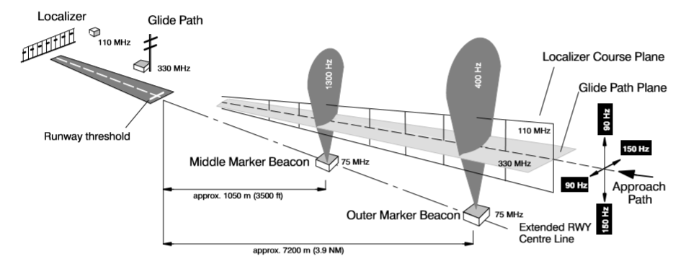

**RADAR :**

Radar is the abbreviation of **RA**dar**D**etection **A**nd**R**anging, which means that radio waves are used detection and ranging measuring.

Radar is an electronic sensing instrument which can be used for detection of remote objects, estimation of various parameters like range, velocity and acceleration of the objects and also for identification of objects.

The radar calculates the range using the signals. The distance between radar and target is calculated by multiplying the time difference between the moments of transmission and reception with the speed of light. The radar pulse transmission, the target reflection and target reception.

**TRANSMISSION:**

The spherical expansion in space of electro-magnetic radar wave transmissions emitted by the radar antenna. The power density of the transmitted wave in space decreases in all directions equally as it moves away from the source and is calculated as the transmitted power divided by the surface of sphere with a radius that equals to that distance.

**TARGET:**

For radar a target is defined by its Radar Cross Section (RCS).The Radar Cross Section depends on the shape and the dimension of the target and the wavelength of the transmitted signal. with this defined Radar Cross Section the target throws back the incoming energy spherically.

**RECEIVING:**

The power density, reflected by the target, will be received by a radar receiver. To receive the reflected target echo an antenna is needed, which collects the power density out of space. The amount of power received depends upon the dimensions.

Detection is the process which presents the target information to the operator.

**TYPES OF RADAR:**

Radar can be positioned in the following ways

1. On the Ground:

Ground based radars has been applied mainly for the detection and location of aircraft or space targets.

1. On the Air:

Airborne radar may be used to detect other aircrafts, ships, or land vehicles, or it may be used for strom avoidance and navigation.

1. On the Sea:

Shipborne radar may observe other ships or aircrafts, or it may be used as a navigation aid to locate shore lines or buoys.

1. In Space :

Used in guiding space vehicles and satellites and for exploration of interplanery space.

**LAND BASED RADARS:**

1. 3D Mobile radar
2. 3D High power static radar
3. Low level detection /surveillance radar
4. Fire control radar
5. Secondary surveillance radar
6. Field artillery radar
7. Battle field surveillance radar
8. Meteorological radar

**CIVILIAN RADARS:**

1. Airport surveillance radar
2. Monopulse secondary surveillance radar

**SHIPBORNE RADARS:**

1. Navigational radars
2. Medium range surveillance radar
3. Long range air warning radar
4. Secondary and SSM control radar

**APPLICATIONS:-**

**DOPPLER WEATHER RADAR:**

**Doppler weather radars(DWRs),integrated with other data sources, particularly satellites, have emerged the world over as one of the most powerful tools for the surveillance and monitoring of severe whether systems such as cyclones and for the estimation of precipitation over a large area.**

**THE DOPPLER EFFECT:**

**In 1842 the Austrian scientist Christian Doppler explained that when one stands near a railroad listening to the sound of a train passing, the train sounds different as it approaches then it does as it recedes. this change is know as the “Doppler effect”.**

**Doppler worked out his ideas using sound waves, but the same principle applies to radars radio waves and to light arriving from distant stars.**

**DOPPLER RADAR WORKS:**

**All weather radars send out radio waves from an antenna. Objects in the air, such as drain drops, snow crystals, hail stones or even insects and dust, scatter or reflect some of radio waves back to the antenna. All weather radars, electronically convert the reflected radio waves into pictures showing the location and intensity of precipitation.**

**Doppler radars also measure the frequency change in returning radio waves.**

**AIR TRAFFIC CONTROL:**

**Radar monitors air traffic in the vicinity of airports and en-route between air terminals. In foul-weather, radar is used with GCA(GROUND CONTROL OF APPROACH) systems to guide aircraft to a safe landing. In the air, commercial aircrafts carry radar altimeters to determine their height above the ground and weather-avoidance radar to navigate around dangerous storms.**

**PLANE POSITION INDICATOR:**

**The plane position indicator radar scans horizontally to give range and bearing. The landing approach radar scans both horizontally and vertically giving range, bearing and elevation.**

**The plane position indicators(PPI) is a radar display where the targets are shown in a plan format. Information obtained from a rotating antenna of radar is displayed on a plane position indicator. This consists of a cathode ray tube with electrodes arranged such as to produce narrow fluorescent line which rotates about the center of the screen. Its rotating is synchronised with that of the antenna so that if, for example, the antenna is directed north, the line is directed vertically up the screen. As the line is scanned from the center to the margin of the screen, it display reflected signals as an increase in brightness of the line.**

**Conclusion :**

CNS having key role in civil aviation. CNS provide safe handling of aircraft and it is used to avoid the aircraft the aircraft collisions. It is also used to maintain air traffic control. Utilizing of navigational aids for clear landing on the runway. Using of radar technology to detect the object in both active and passive points along with its all parameters.

Finally, it was shown that the role of CNS control the air vehicles without any accidents happened and reach the aircraft’s destination points safely.

Future scope:

Radar plays a key role in civil aviation. Next advanced and upcoming technology on civil aviation is GPS (Global positioning system).